**VGG16**

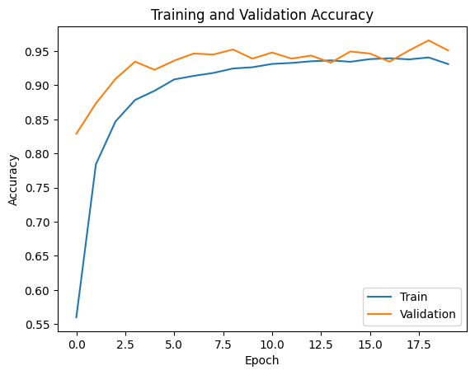

**ResNet50**

**InceptionV3**

**Xception**

**MobileNetV2**

**EfficientNetB0**

**DenseNet121**

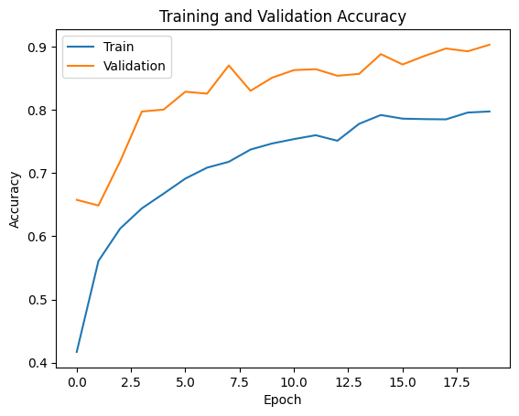

**NASNetMobile**

**InceptionResNetV2**

**Input Images**  
(244 x 244 x 3)

**Output**

**Input Images**  
(244 x 244 x 3)

**VGG16**  
(excluding the final layer)  
  
Input: 244 x 244 x 3  
Output: 6 x 6 x 2048

**Global Average Pooling Layer**  
(2048 nodes)

**Fully Connected Layer**  
(256 nodes)

**Softmax Layer**(11 nodes)

**Dropout Layer**  
(0.5)

**Output**

**VGG16**  
(excluding the final layer)  
  
Input: 244 x 244 x 3  
Output: 6 x 6 x 2048

**Global Average Pooling Layer**  
(2048 nodes)

**Fully Connected Layer**  
(256 nodes)

**Softmax Layer**(11 nodes)

**Dropout Layer**  
(0.5)

**InceptionV3**  
(excluding the final layer)  
  
Input: 244 x 244 x 3  
Output: 6 x 6 x 2048

**ResNet50**  
(excluding the final layer)  
  
Input: 244 x 244 x 3  
Output: 1 x 1 x 2048

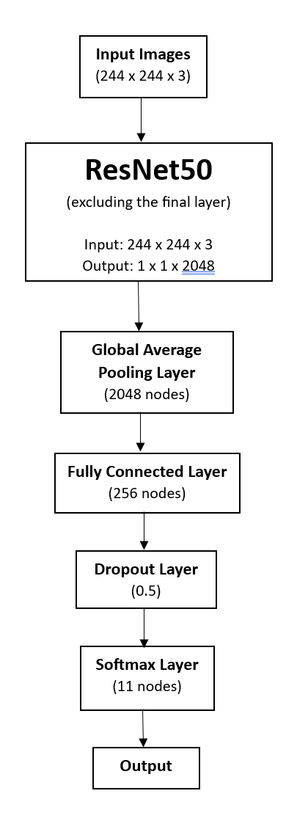

**Output**

**Input Images**  
(244 x 244 x 3)

**DenseNet121**  
(excluding the final layer)  
  
Input: 244 x 244 x 3  
Output: 6 x 6 x 2048

**Global Average Pooling Layer**  
(2048 nodes)

**Fully Connected Layer**  
(256 nodes)

**Softmax Layer**(11 nodes)

**Dropout Layer**  
(0.5)

**Output**

**Input Images**  
(244 x 244 x 3)

**Global Average Pooling Layer**  
(2048 nodes)

**Fully Connected Layer**  
(256 nodes)

**Softmax Layer**(11 nodes)

**Dropout Layer**  
(0.5)

**InceptionRestNetV2**  
(excluding the final layer)  
  
Input: 244 x 244 x 3  
Output: 6 x 6 x 2048